****Name: _____**SOLUTIONS**___________

Full Test (Sections 1 and 2)

Total Time: 50 minutes

Total Marks: 45 marks

Student Result ________/ 45

**MATHEMATICS METHODS Unit 1**

**TEST 1B -2018**

**Quadratics, Polynomials and Other Functions**

**Calculator Free Section**

Time: 20 minutes

Total Marks: 18 marks

Resources allowed: SCSA Formula Sheet

**Instructions to candidates**

Show all your working clearly. Your working should be in sufficient detail to allow your answers to be checked readily and for marks to be awarded for reasoning. Incorrect answers given without supporting reasoning cannot be allocated any marks**. For any question or part question worth more than two marks, valid working or justification is required to receive full marks.** If you repeat any question, ensure that you cancel the answer you do not wish to have marked.

|  |  |
| --- | --- |
| **Question 1** | **[1, 2, 3 = 6 marks]** |

Solve the following equations, exactly.

a) $x^{2}-64=0$

$\left(x-8\right)\left(x+8\right)=0$ or $x^{2}=64$

$x=8$ or ✓ both correct

b)

✓ collects terms to one side and factorises

$x=2$ or ✓ both correct

c)

✓ uses quadratic formula or completes the square

✓ correct prior to simplification

✓ correct simplification

|  |  |
| --- | --- |
| **Question 2** | **[4 marks]** |

The cubic equation $x^{3}-x^{2}-44x+84=0$, has $x=6$ as a solution.

Fully factorise $x^{3}-x^{2}-44x+84$ and hence determine all solutions to the equation.

✓ uses factor theorem to obtain linear and general quadratic factor

matching coefficients

✓ determines quadratic factor

✓ fully factorises cubic

Solutions are ✓ determines all solutions

|  |  |
| --- | --- |
| **Question 3** | **[5 marks]** |

Given the quadratic function, $y=-2x^{2}+20x-42$, determine:

a) the equation for the line of symmetry.

✓

b) the coordinates of the turning point.

$f\left(5\right)=-50+100-42=8$ T.P. = (5, 8) ✓

c) the coordinates of the *y*-intercept.

$f\left(0\right)=-42$*y*-intercept = (0, −42) ✓

d) the coordinates of the roots of the function.

✓ correctly factorises quadratic

roots at (3, 0) and (7, 0) ✓ correct

|  |  |
| --- | --- |
| **Question 4** | **[3 marks]** |

Sketch the function $y=\sqrt{-x+4}$ on the Cartesian plane below.

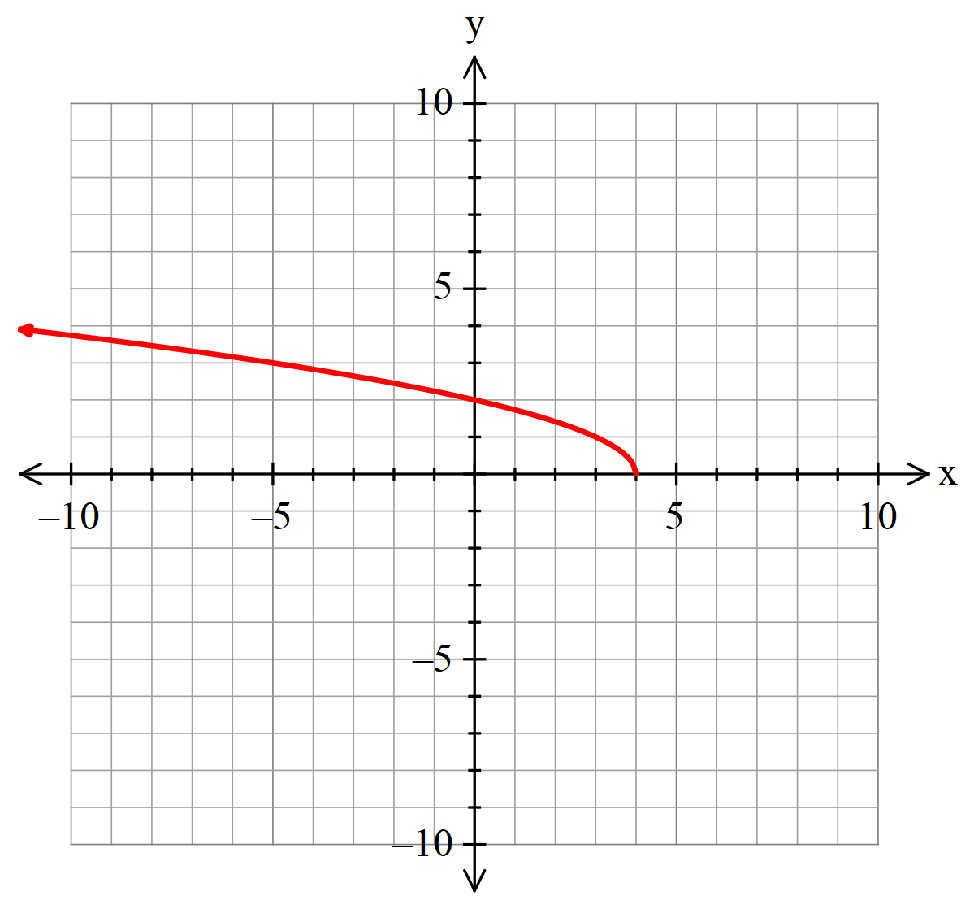

✓ correct shape and passes through (0, 2)

✓ correct reflection about the *y*-axis

✓ correct root at (4, 0)

 Name: _____**SOLUTIONS**___________

**MATHEMATICS METHODS Unit 1**

**TEST 1B -2018**

**Quadratics, Polynomials and Other Functions**

**Calculator Assumed Section**

Time: 30 minutes

Total Marks: 27 marks

Resources allowed:

SCSA Formula Sheet

Up to three Calculators and

One A4 sheet, both sides of notes

**Instructions to candidates**

Show all your working clearly. Your working should be in sufficient detail to allow your answers to be checked readily and for marks to be awarded for reasoning. Incorrect answers given without supporting reasoning cannot be allocated any marks. **For any question or part question worth more than two marks, valid working or justification is required to receive full marks.** If you repeat any question, ensure that you cancel the answer you do not wish to have marked.

|  |  |
| --- | --- |
| **Question 5** | **[6 marks]** |

Below are three functions, each in one of the following forms.

$f\left(x\right)={\left(ax-2\right)}^{2}$ $g\left(x\right)=\left(bx-5\right){\left(x-c\right)}^{2}$ $h\left(x\right)=\frac{d}{x-k}+m$

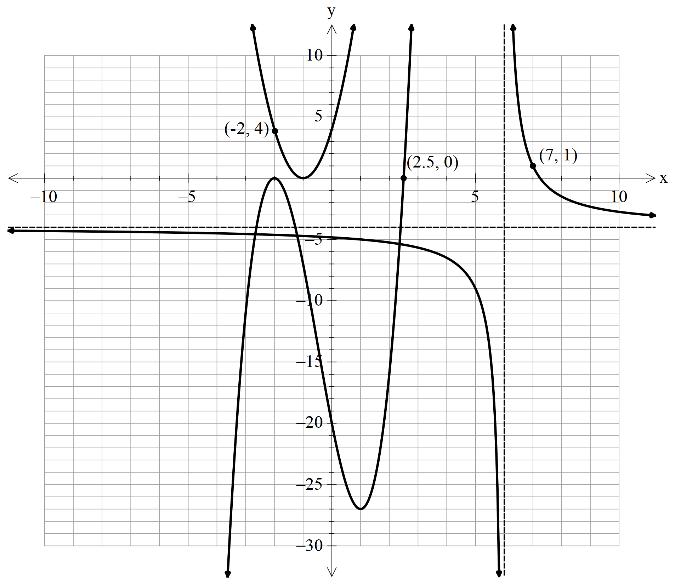

Determine the values of *a, b, c, d, k* and *m.*

✓

✓

✓

✓

✓

✓

|  |  |
| --- | --- |
| **Question 6** | **[4 marks]** |

The graph of $y=f(x)$ is shown below as the solid curve.

The function under goes a number of transformations and the dashed curve, $y=g(x)$, is the result of those transformations on $y=f(x)$.

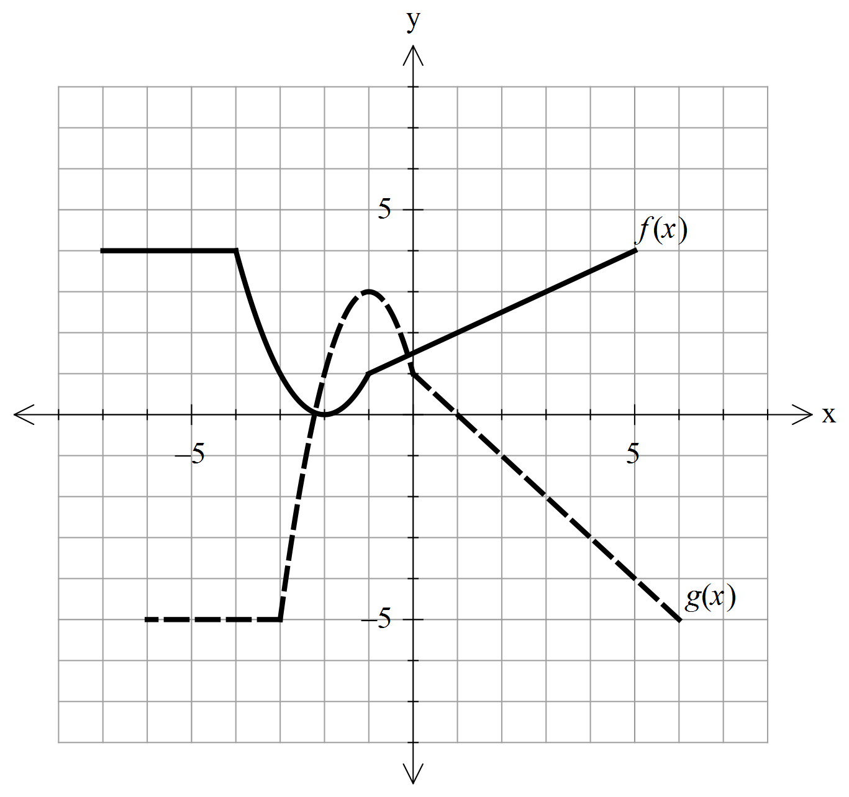

Write the function $g(x)$ in terms of

✓ correct horizontal translation

✓ correct reflection about the *x*-axis

✓ correct vertical dilation

✓ correct vertical translation $f\left(x\right)+3$

|  |  |
| --- | --- |
| **Question 7** | **[3, 2 = 5 marks]** |

Determine the equation for each of the following relations.

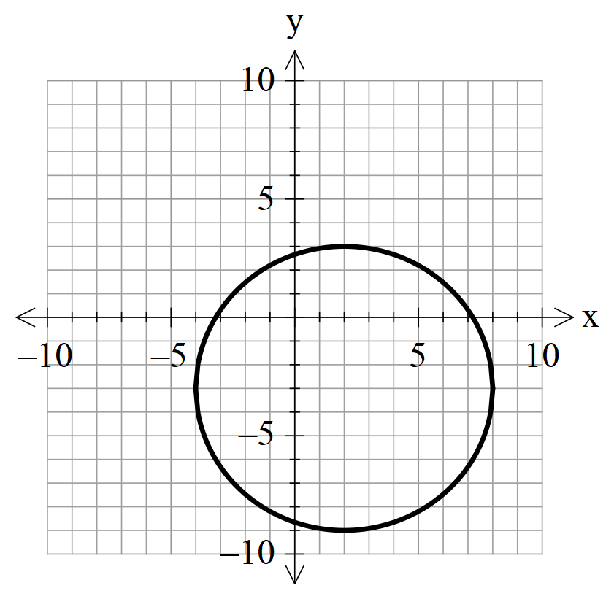

a)

✓ correct form for the equation of a circle

✓ correct horizontal and vertical translation related to the centre

✓ correct constant related to radius squared

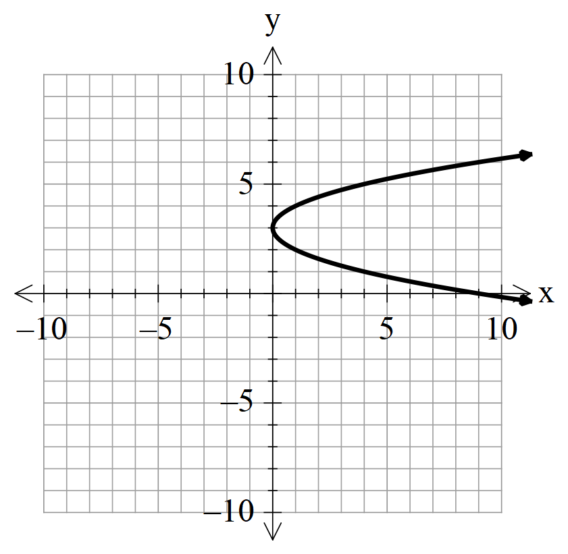

b)

✓ correct form for the equation of a horizontal parabola

✓ correct vertical translation

|  |  |
| --- | --- |
| **Question 8** | **[3 marks]** |

A quadratic function has a turning point at (2, 7) and passes through the point (5, 43).

Determine the equation of the function in the form $y=ax^{2}+bx+c$

Given T.P. at (2, 7) the function can be expressed in the form $y=a{(x-2)}^{2}+7$

Substitute in point (5, 43) to solve for *a* ✓ uses T.P. to put in general vertex form

✓ subst. (5, 43) to solve for dilation factor

$43=9a+7$

$a=4$

Expanding ✓ expands to correct form

|  |  |
| --- | --- |
| **Question 9** | **[1, 2, 2, 2, 2 = 9 marks]** |

A particle P moves back and forth along a straight line. Its displacement $t$ seconds after passing a fixed

point O is given by $s=0.25t^{3}-3.25t^{2}+10t$ metres, for $0≤t≤10$ seconds.

Graph the displacement $s$ against $t$ on your graphic calculator. Use an appropriate routine to find:

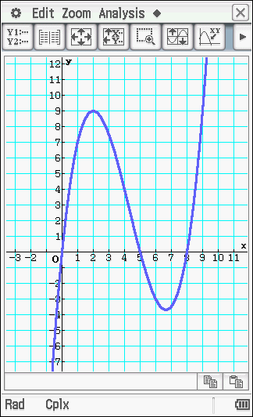a) the displacement of P when $t=10$ seconds

when $t=10$, $s=0.25\left({10}^{3}\right)-3.25\left({10}^{2}\right)+10(10)$

$s=25$ metres ✓

b) the farthest P is from O for $0≤t≤5$ seconds.

Analysis, G-Solve, Max

✓ T.P.max

∴ 9 metres ✓ correct (2 marks if answer only)

c) the farthest P is from O for $5≤t≤8$ seconds.

Analysis, G-Solve, Min

✓ T.P.min

∴ 3.704 metres ✓ correct (2 marks if answer only)

d) the time(s) the particle P returns to the fixed point O.

Analysis, G-Solve, Roots (0, 0) (5, 0) and (8, 0)

✓ Roots

Particle P starts at fixed point O at $t=0$

then returns at $t=5$ and $t=8$ seconds ✓ correct (2 marks if answer only)

e) the total distance particle P has travelled in the first 10 seconds.

Total distance ✓ doubles maximum distances obtained in

parts b) and c)

Total distance $≈50.4$ metres ✓ correct (2 marks if answer only)